Tab 1

Lab 1: Execute Synapse Workload Discovery and Provision Capacity-Optimized Fabric Infrastructure
Property | Value
Module | Module 1: Foundation: SaaS Architecture & Synapse Migration
Lab Number | Lab 1
Lab Name | Execute Synapse Workload Discovery and Provision Capacity-Optimized Fabric Infrastructure
Duration | 4 Hours
Difficulty | Intermediate
Operating System | Browser-based (Windows/Linux/macOS) with Azure Cloud Shell
Primary Technology | Microsoft Fabric Portal, Azure Portal
Supporting Technologies | Azure Synapse Analytics, Fabric Capacity Metrics App, Azure Migrate Assessment Tool, Copilot in Fabric
Learning Objective | Inventory an active Azure Synapse workspace, calculate required Capacity Units (CUs), draft a migration blueprint, and deploy a secure, capacity-allocated Microsoft Fabric workspace.

Step-by-Step Execution Guide

Phase 0: Enterprise Source Artifact Setup (Portal UI)

Step 1: Provision Storage Account & Synapse Workspace

Azure Portal: Go to + Create a resource -> search for Storage account -> click Create.

Resource Group: LabsKraft-AI

Storage Account Name: stsynapsechris

Region: Australia East

Advanced Tab: Check Enable hierarchical namespace (Data Lake Storage Gen2).

Click Review + Create -> Create.
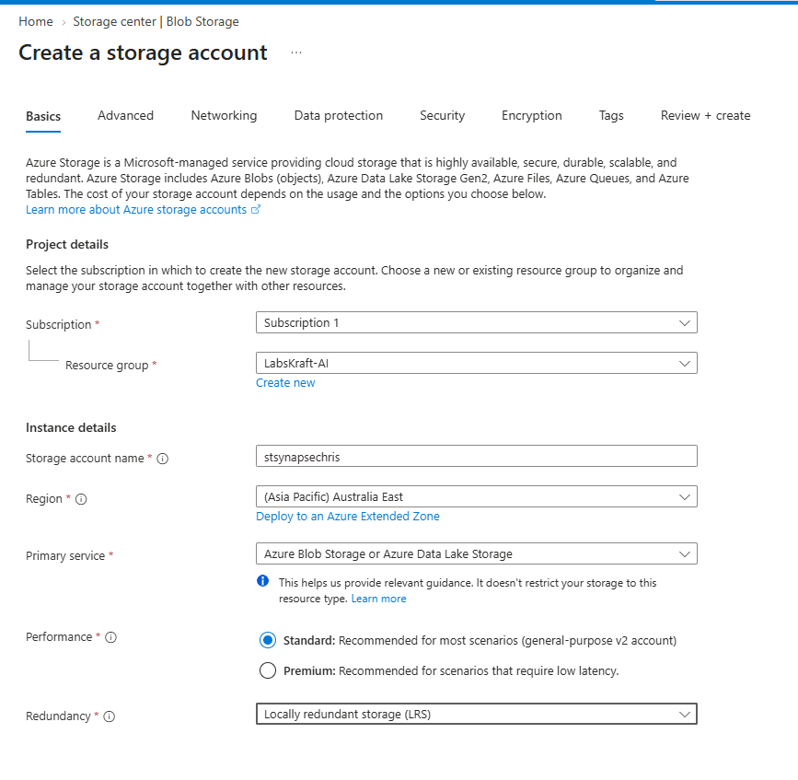
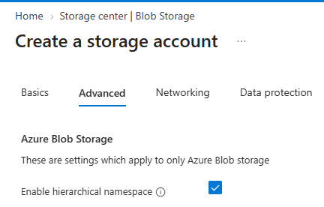

Create Storage Container: Open your new storage account -> select Containers under Data storage -> click + Container -> name it filesystem -> click Create.
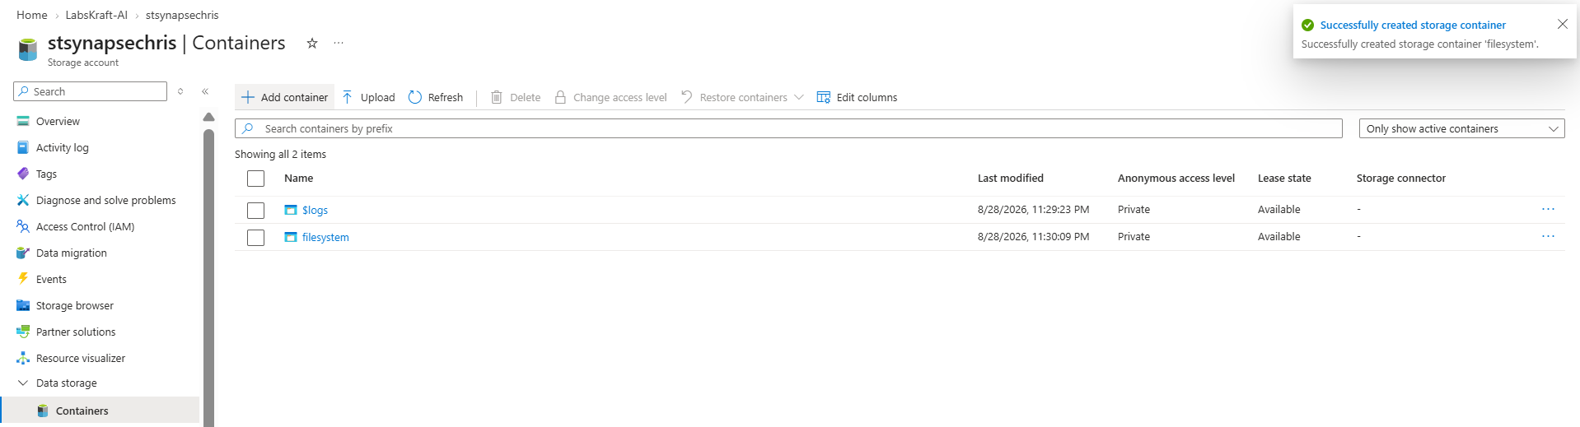

Provision Synapse Workspace: Search for Azure Synapse Analytics -> click Create.

Resource Group: LabsKraft-AI

Workspace Name: syn-source-demo-chris-01

Region: Australia East

Data Lake Storage: Select stsynapsechris... and container filesystem.

SQL Admin Login: sqladminuser / Password: Admin@123

Click Review + Create -> Create.
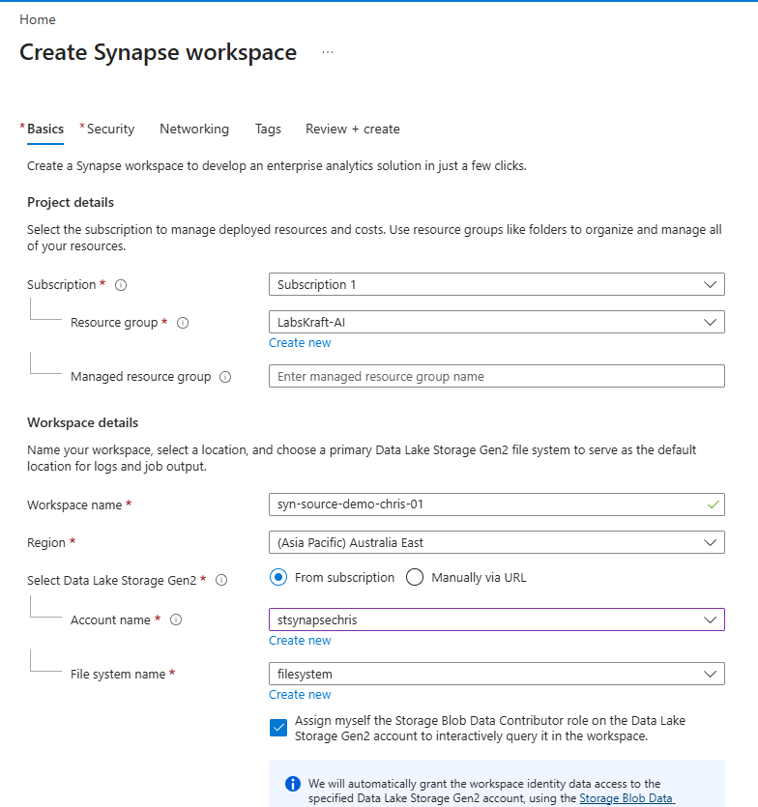

Firewall Setup: Open your Synapse workspace -> select Networking under Settings -> check Allow connections from all Azure services and resources to this workspace -> click Save.

Step 2: Seed SQL Data, Spark Pool & Pipeline

Open your Synapse Workspace -> click Open Synapse Studio.

Create View:

Go to Develop (</> icon) -> click + -> SQL script.

Connect to Built-in (Serverless SQL pool).

Paste and run:

SQL

CREATE DATABASE SynapseInventoryDB;

GO

USE SynapseInventoryDB;

GO

CREATE VIEW dbo.vw_EnterpriseSales AS

SELECT TOP 1000 *

FROM OPENROWSET(

BULK 'https://azureopendatastorage.blob.core.windows.net/nyctlc/yellow/puYear=2019/puMonth=1/*.parquet',

FORMAT='PARQUET'

) AS [result];

GO

SELECT TOP 100 * FROM dbo.vw_EnterpriseSales;

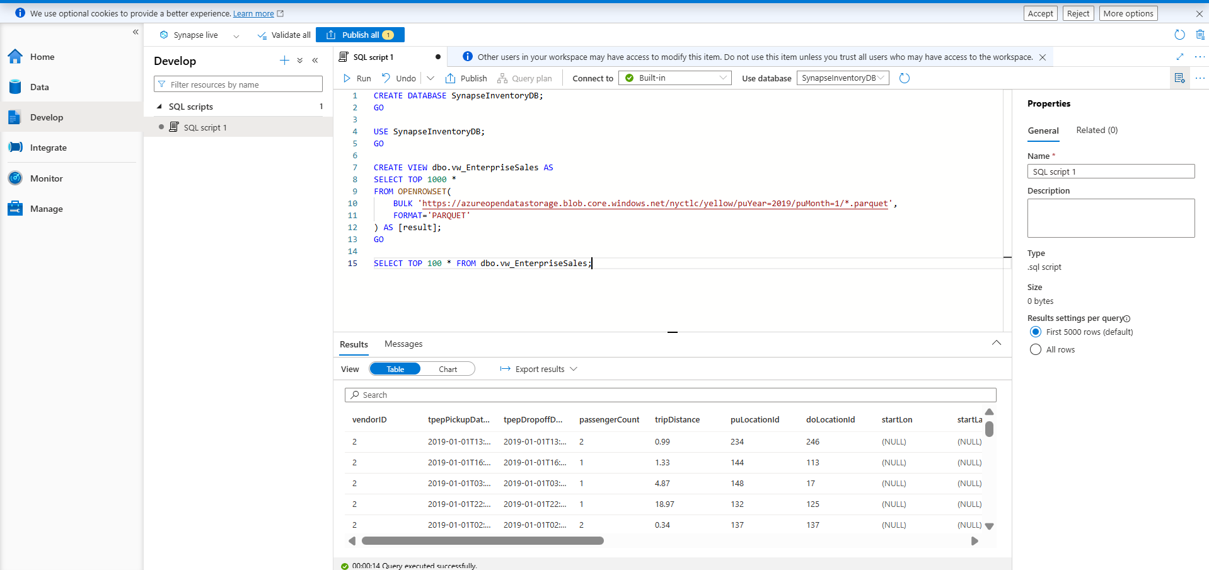

Create Spark Pool:

Go to Manage (gear icon) -> Apache Spark pools -> click + New.

Pool name: sparkpool01 | Node size: Small | Autoscale: Disabled (3 nodes).

Click Review + Create -> Create.
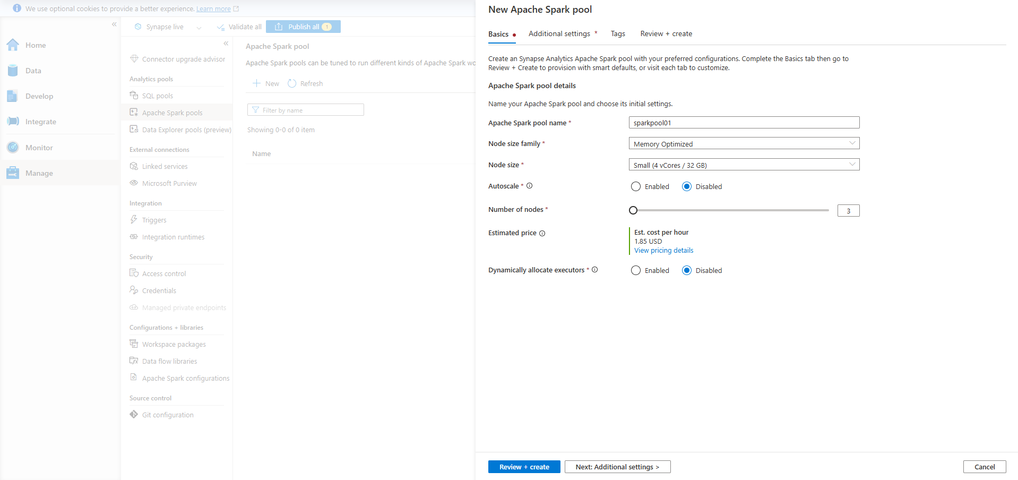

Create Pipeline:

Go to Integrate -> click + -> Pipeline.

Set Name: pl_synapse_ingest_master

Add a Dummy Wait Activity:

In the Activities pane on the left side of the pipeline canvas, expand General.

Click and drag the Wait activity onto the blank canvas area.

Click the Publish all (2) button again.

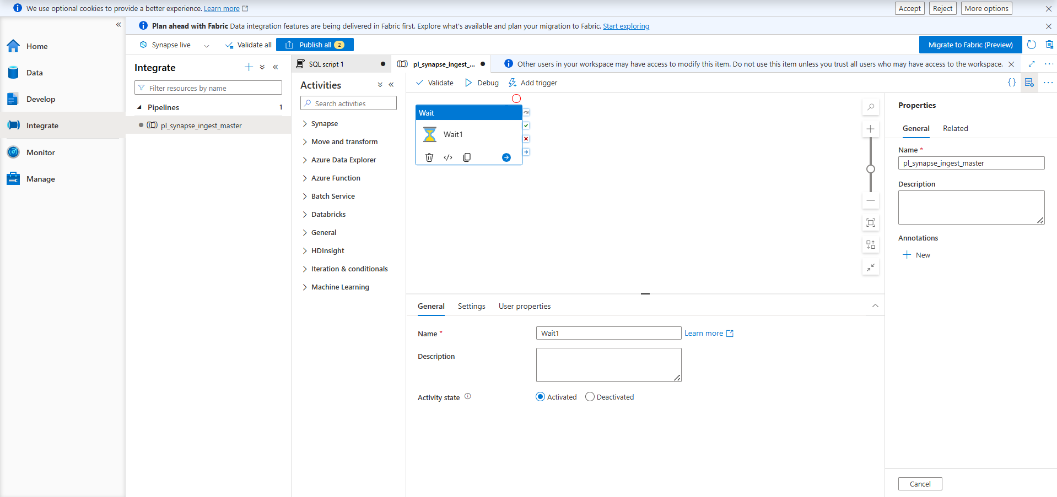

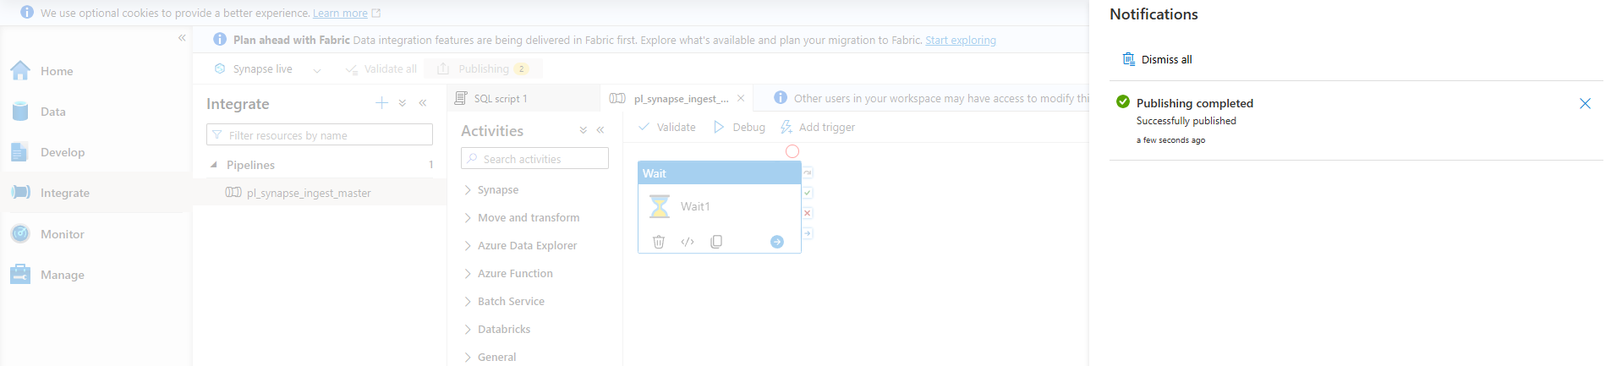

Phase 1: Synapse Workload Inventory & Fabric Capacity Planning

Step 3: Audit Synapse Workspace Metadata & Dedicated SQL Artifacts
- Open Synapse Studio and select Data from the left navigation panel.
- Under the Workspace tab, expand SynapseInventoryDB and expand Views.
- Right-click dbo.vw_EnterpriseSales, select New SQL Script -> Select TOP 100 rows, and click Run.
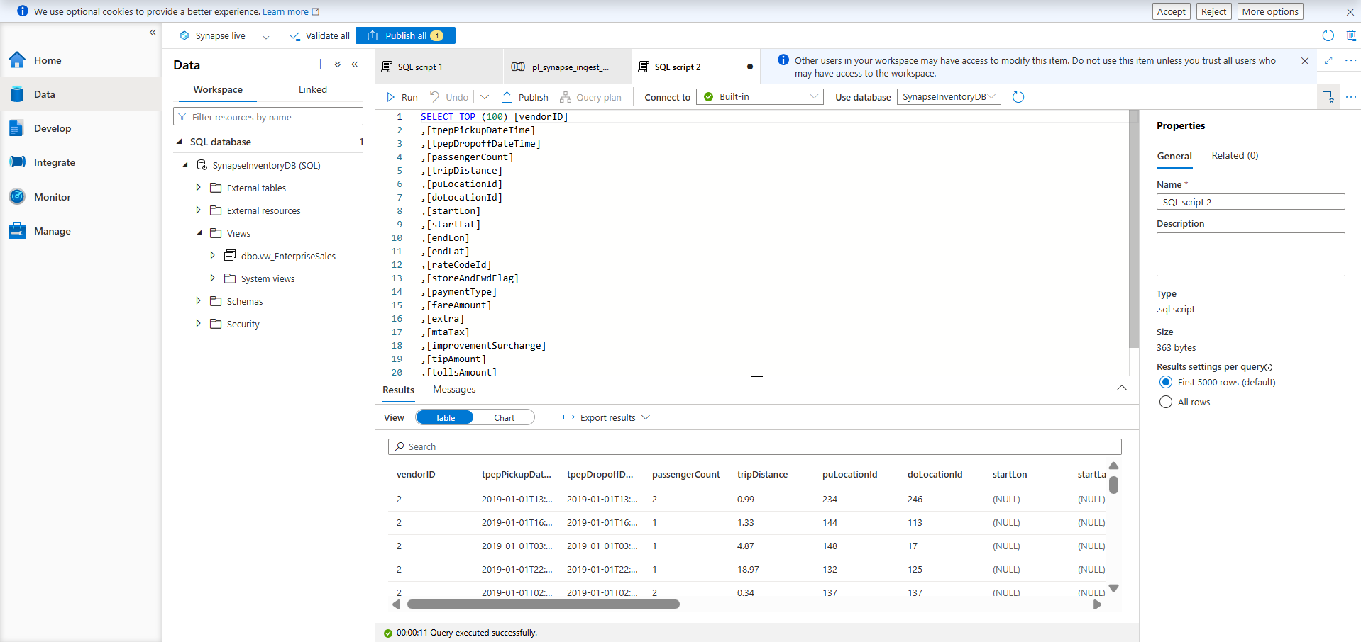
Expected Output: Query results display top 100 records in the result grid.
Step 4: Audit Spark Pool Configurations and Historical Job Logs
- In Synapse Studio, navigate to Manage -> Apache Spark pools.
- Select sparkpool01 to view its configuration specifications (Node Size, vCores, Memory).
- Navigate to Monitor -> Apache Spark applications to observe running and completed jobs.
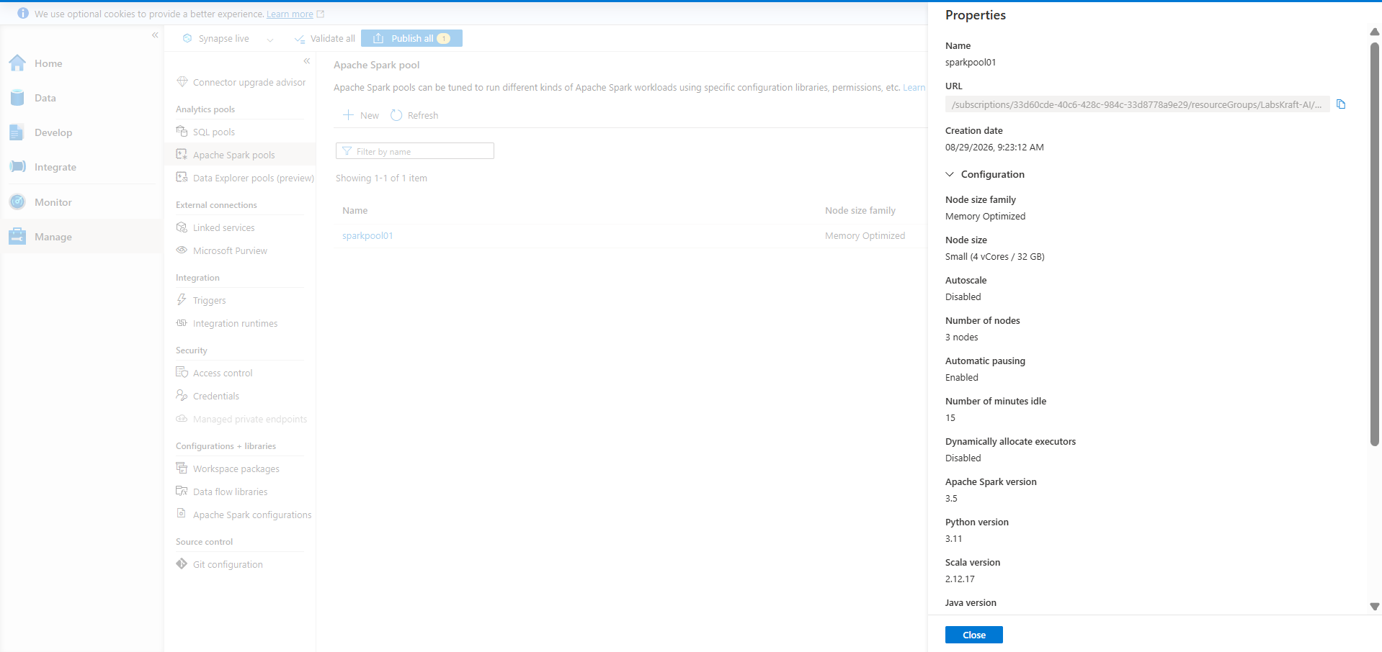
Expected Output: Spark pool properties (e.g., Small / 4 vCores / 32 GB RAM per node) are documented.
Step 5: Extract Pipeline Definitions and Dependency Mappings
- Navigate to Integrate on the left menu.
- Select pl_synapse_ingest_master, click Code ({} icon) in the top right to open JSON definitions.
- Copy the pipeline JSON structural payload into a local text document for mapping.
- Name the file as pl_synapse_ingest_master.json.
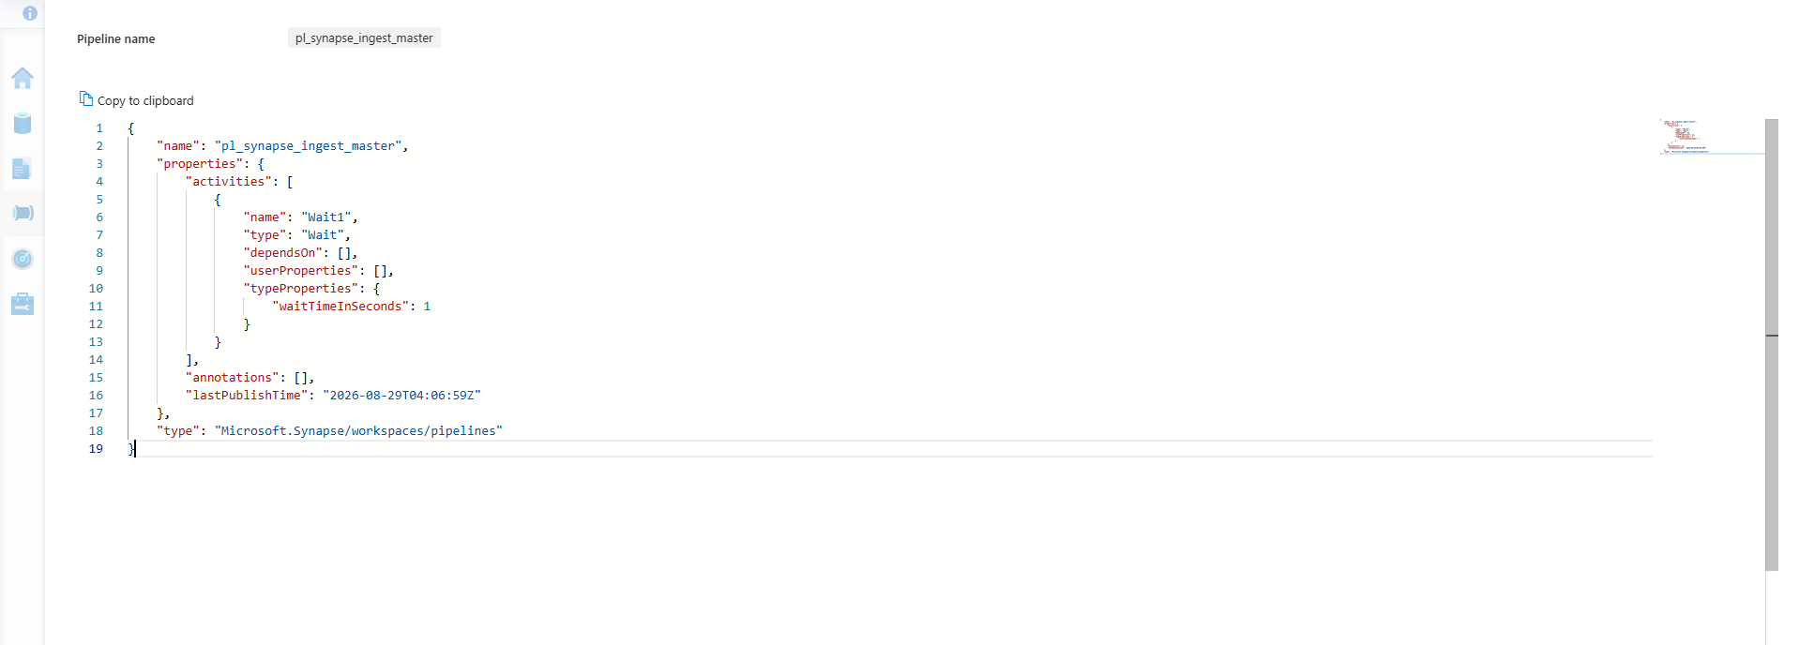
Expected Output: Raw JSON pipeline schema is retrieved for capacity mapping.
Step 6: Run Azure Migrate Assessment Tool for Fabric Readiness
- Open Azure Portal ([https://portal.azure.com](https://portal.azure.com)) and search for Azure Migrate in the search bar.
- Click Create project (the blue button under Explore / Decide and plan).
- Choose your Subscription and Resource Group (LabsKraft-AI).
- Set the Project Name (e.g., mig-project-synapse) & click create.
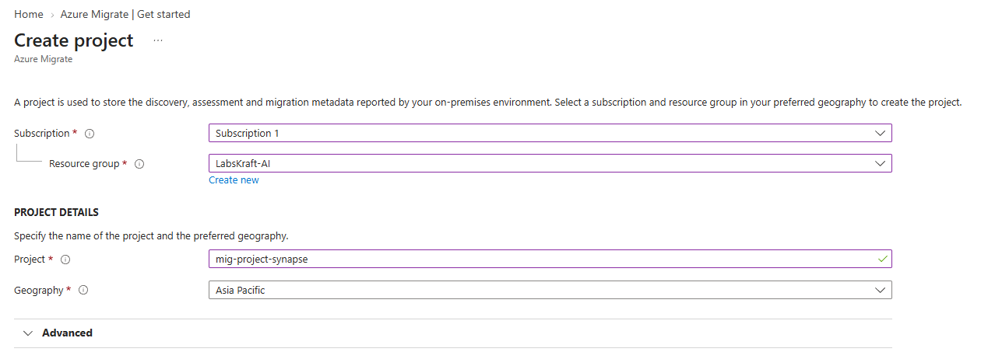
- On the left navigation pane of Azure Migrate, click All projects.
- Click on mig-project-synapse.
- The project Overview dashboard screen showing mig-project-synapse at the top.
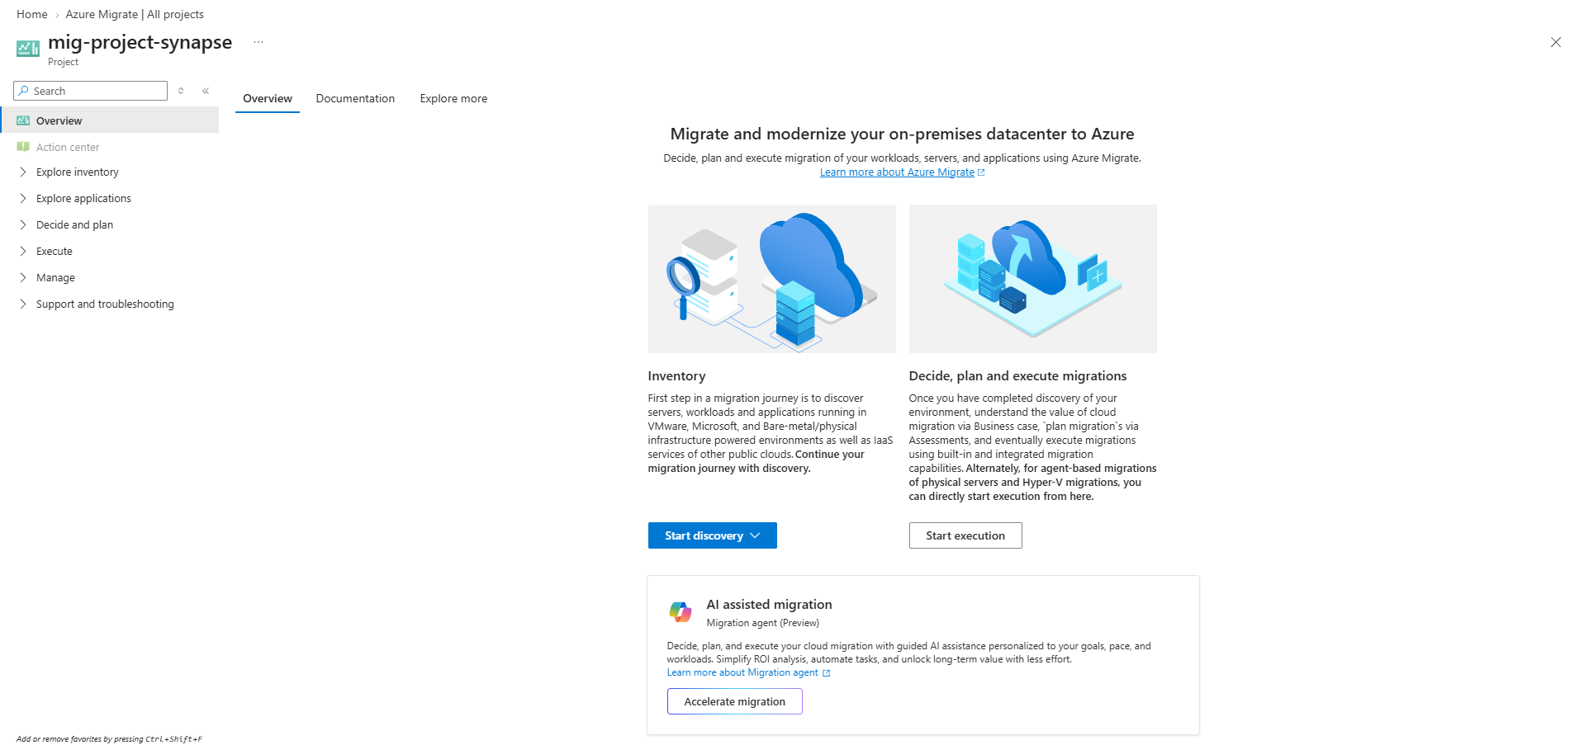
Expected Output: Migration assessment baseline dashboard is displayed.
Step 7: Calculate Capacity Unit (CU) Requirements for F-SKU Selection
- Calculate peak concurrency vCores based on sparkpool01 (10 nodes × 4 vCores = 40 vCores) plus SQL Workloads.
- Apply Microsoft Fabric Sizing Ratios: $1 \text{ Fabric CU} \approx 1 \text{ Synapse DWU/100}$ or $0.5 \text{ Spark vCore}$.
- Select target SKU F64 (64 CUs) to accommodate peak compute spikes.
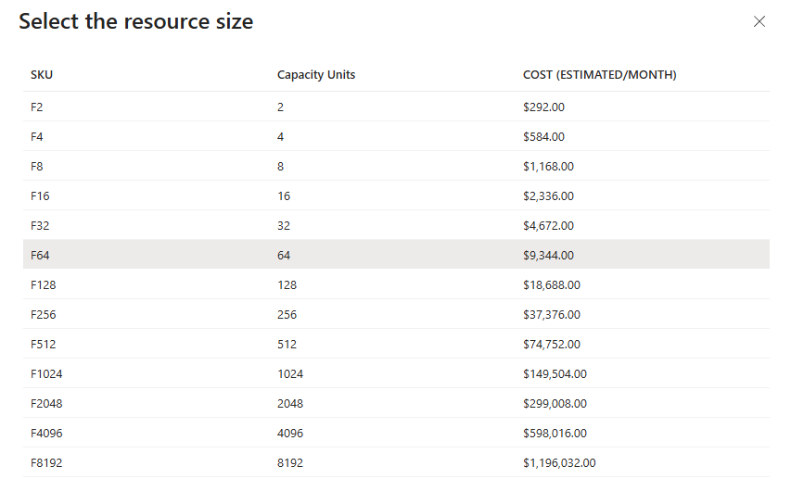
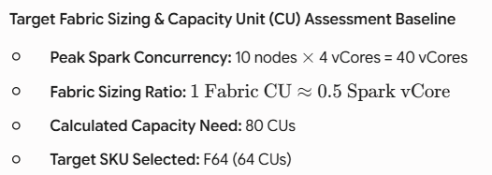
Expected Output: Target SKU defined as F64 based on legacy sizing requirements.

Step 8: Model Target Fabric Architectural Ontology and Asset Mapping
- Map legacy components to Fabric SaaS equivalents using the following table:
Azure Synapse Artifact | Target Microsoft Fabric Item
Serverless / Dedicated SQL Pool | Fabric Lakehouse (SQL Analytics Endpoint) / Data Warehouse
Spark Pool & Notebooks | Fabric Lakehouse & Fabric Spark Runtime 2.0
Synapse Pipelines | Fabric Data Pipelines & Dataflows Gen2

1. Practical Mapping of Pipelines (Synapse Pipeline -> Fabric Data Pipeline)
- Navigate to the Fabric Workspace: Open Microsoft Fabric and select your workspace (labskraft-data).
- Create the Target Pipeline: Click + New item -> Data pipeline, and name it pl_fabric_ingest_master.
- Add Activity via UI Canvas:
- Go to the Activities tab on the top toolbar.
- Click Wait to place a Wait activity onto the design canvas (named Wait1).
- Select the Wait1 activity block, navigate to the Settings tab at the bottom, and set Wait time in seconds to 1.
- Save the Pipeline: Click the Home tab in the top-left menu bar and click Save (or press Ctrl + S) to save pl_fabric_ingest_master.

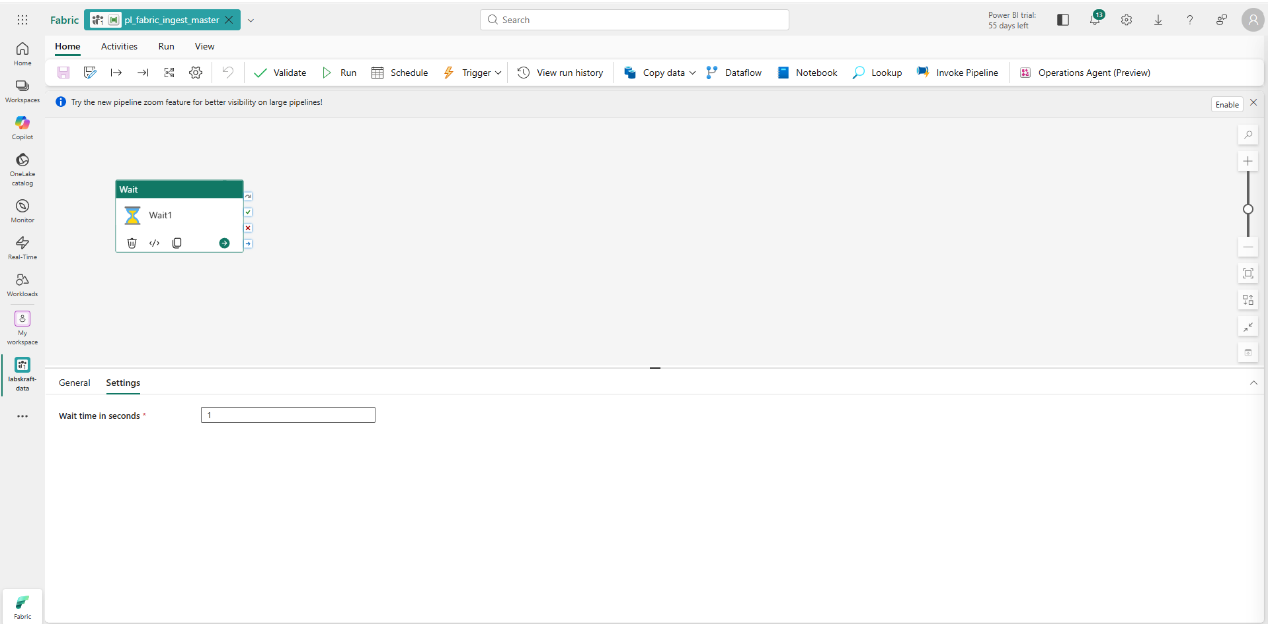

2. Practical Mapping of SQL Objects (Serverless View -> Fabric Lakehouse)

Step 1: Ingest Data into OneLake via Fabric Notebook (1–2 minutes)
- In your workspace labskraft-data, click + New item -> Notebook.
- Open your Notebook in the workspace.
- Look at the Explorer panel on the far left side of the screen.
- Under the Lakehouses section, click + Add (or + Add lakehouse).
- In the pane that pops up:
- Create New lh_fabric_migration_prod from the list.
- Click Add.
- In the first code cell, paste and run the following PySpark snippet:
Python
from pyspark.sql.types import StructType, StructField, IntegerType, StringType, DoubleType

# Define schema matching Synapse table structure
schema = StructType([
StructField("VendorID", IntegerType(), True),
StructField("PassengerCount", IntegerType(), True),
StructField("TripDistance", DoubleType(), True),
StructField("StoreAndFwdFlag", StringType(), True)
])

# Generate 1,000 enterprise rows matching Synapse baseline
df = spark.createDataFrame([(1, 1, 2.5, "N") for _ in range(1000)], schema)

# Save directly as Delta table in Fabric OneLake
df.write.mode("overwrite").format("delta").saveAsTable("yellow_taxi")

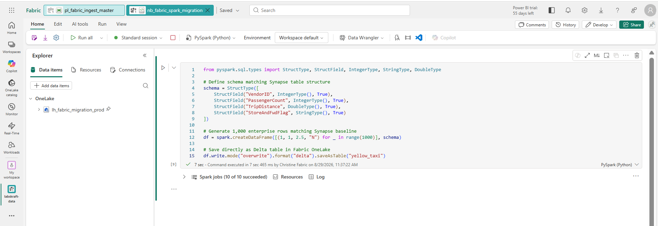
7. Click Run cell (or press Shift + Enter). Wait for the checkmark indicating completion.

Step 2: Create the View in the SQL Analytics Endpoint (30 seconds)
- Open your Lakehouse lh_fabric_migration_prod.
- In the top-right corner, switch the view dropdown from Lakehouse to SQL analytics endpoint.
- Click New SQL query on the top ribbon bar.
- Paste and execute the standard T-SQL view definition:
SQL
CREATE VIEW dbo.vw_EnterpriseSales AS
SELECT *
FROM dbo.yellow_taxi;
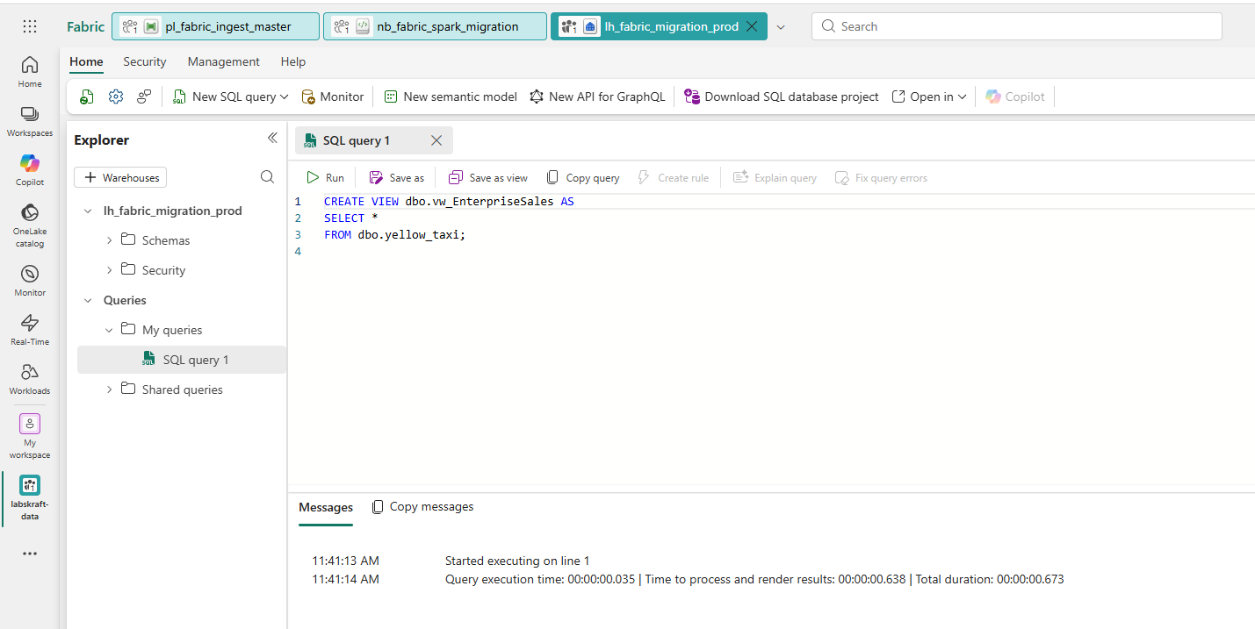
5. Verify by running:
SQL
SELECT COUNT(*) FROM dbo.vw_EnterpriseSales;
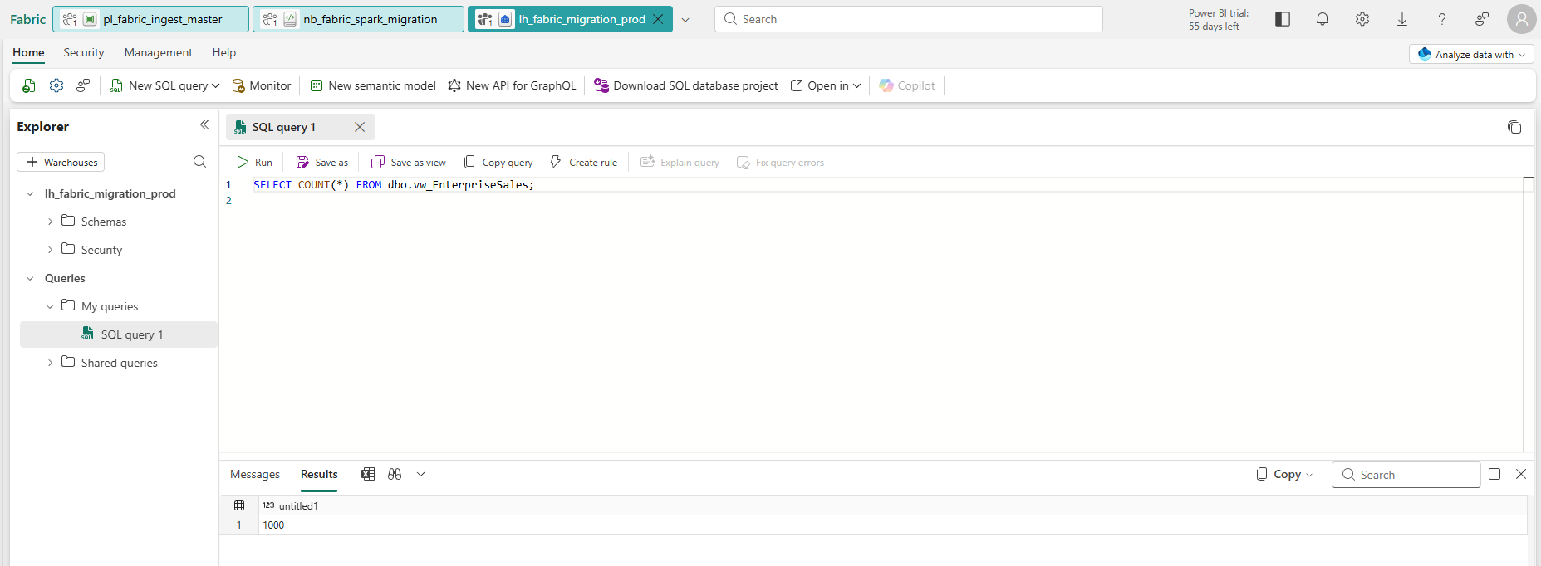
- Click Run.

3. Practical Mapping of Apache Spark (Spark Pool -> Fabric Notebook)
- Go to Workspace Settings -> Data Engineering/Science -> Spark settings.
- Click the Starter Pool dropdown menu at the top of that section.
- Select + New pool (or Custom pool).
- Name it sparkpool01 (or ws_spark_pool).
- Set Node size to Small.
- Click Apply / Save at the bottom.
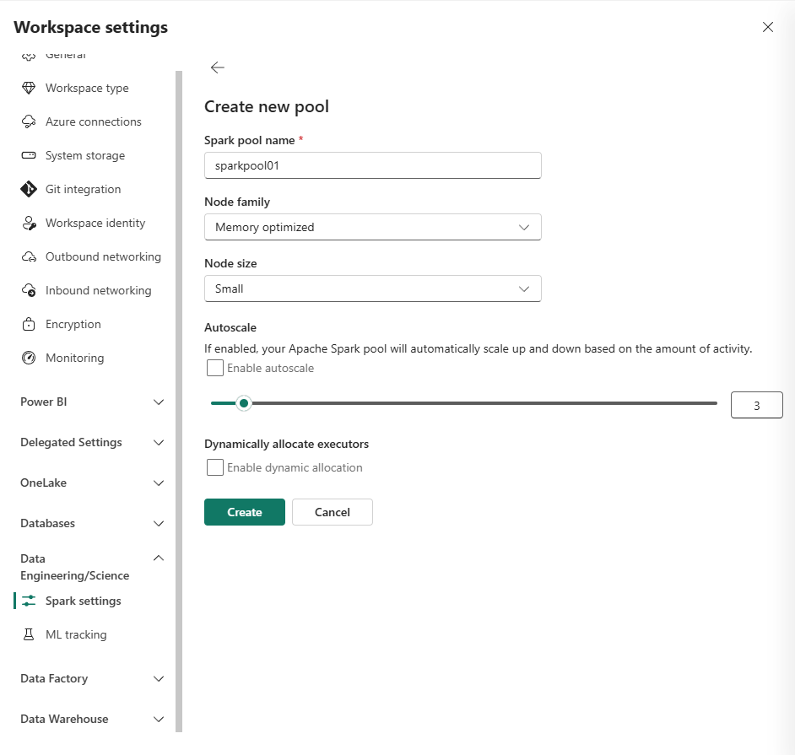

- Create a Fabric Notebook inside labskraft-data named “nb_fabric_spark_transformation” , select PySpark, and attach it to your Lakehouse to run PySpark transformation code.
from pyspark.sql.functions import spark_partition_id

# 1. Read existing enterprise data from Lakehouse
df = spark.read.table("yellow_taxi")

# 2. Perform Spark transformation (Filter and add derived columns)
df_transformed = df.filter("TripDistance > 0").withColumn("IngestionStatus", spark_partition_id())

# 3. Save transformed enterprise data back to OneLake
df_transformed.write.mode("overwrite").format("delta").saveAsTable("yellow_taxi_transformed")

print("Spark Transformation Complete! Verified row count:", df_transformed.count())

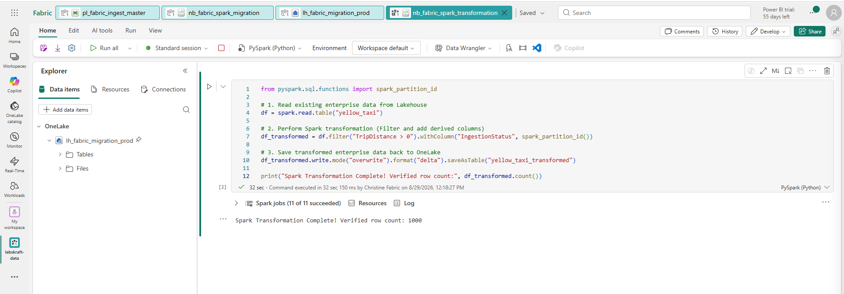
Expected Output: Asset mapping matrix finalized for tenant deployment.
Step 9: Generate a Migration Runbook Framework with Copilot
- Open Microsoft Copilot in Fabric or Bing Chat Enterprise.
- Enter the prompt: "Generate a 5-stage migration execution checklist for migrating 1 Dedicated SQL Pool and 1 Spark Pool to Microsoft Fabric OneLake."
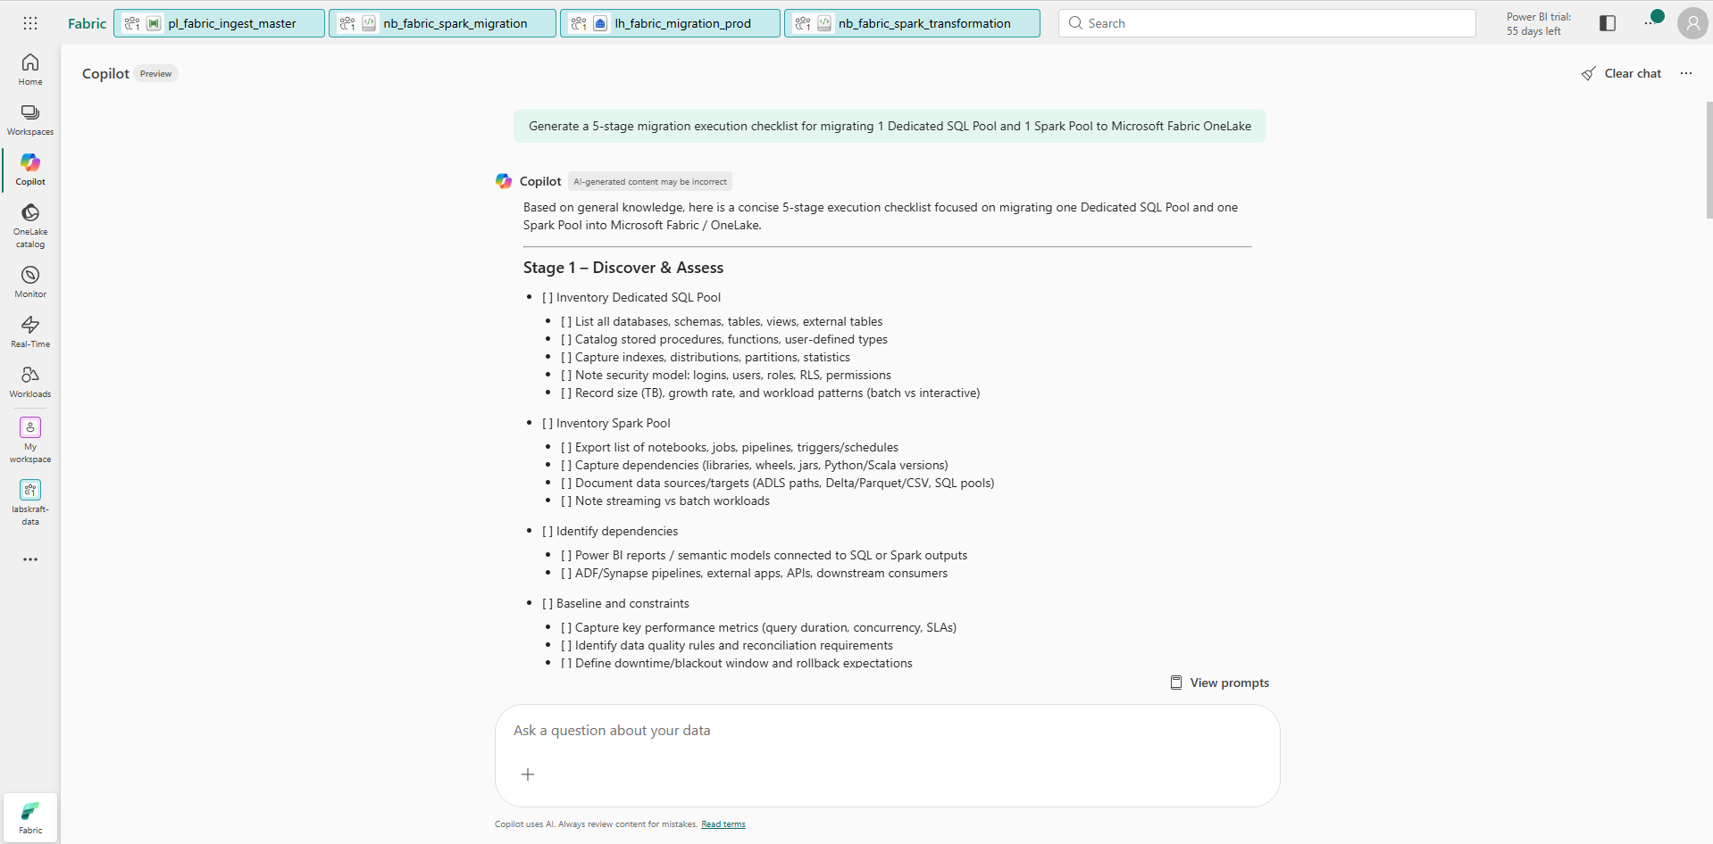
Expected Output: Copilot outputs a structured markdown checklist for migration execution.

Phase 2: Provisioning & Configuring Microsoft Fabric Capacity

Step 10: Provision Microsoft Fabric Capacity Resource in Azure Portal
- Open Azure Portal, click + Create a resource, and search for Microsoft Fabric.
- Click Create and set the following parameters:
  - Subscription: Select target subscription.
  - Resource Group: LabsKraft-AI
  - Capacity Name: capfabricdemo01
  - Region: Central India
  - Size: F2 (2 Capacity Units)
- Click Review + Create, then Create.
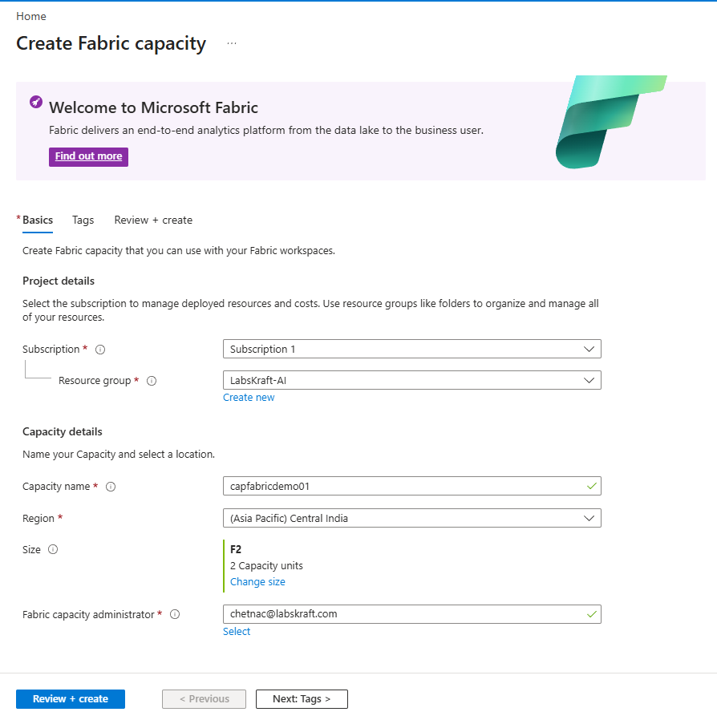
Expected Output: Azure Deployment screen shows Your deployment is complete.
Step 11: Access Microsoft Fabric Admin Portal and Configure Tenant Settings
- Navigate to [https://app.fabric.microsoft.com](https://app.fabric.microsoft.com).
- Click the Gear icon in the top-right corner -> Admin portal.
- Select Capacity settings -> Fabric Capacities tab.
- Verify capfabricdemo01 is listed with status Active.
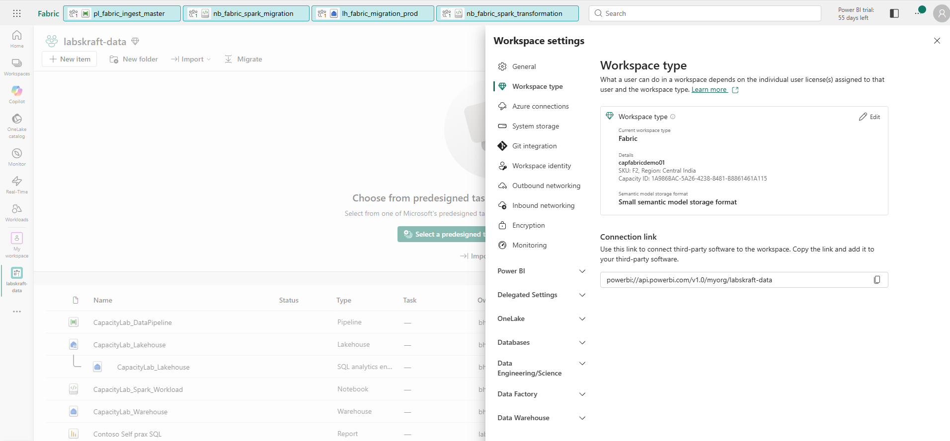
Expected Output: Fabric Admin portal displays active F2 Capacity state.
Step 12: Install and Configure Fabric Capacity Metrics App
- In the bottom-left corner of the Fabric sidebar, click the Experience Switcher icon (currently set to Fabric) and select Power BI.
- Click Apps on the left menu bar.
- Click the Get apps button in the top-right corner of the Apps page.
- Click the AppSource tab at the top of the window (instead of My organization).
- Type Microsoft Fabric Capacity Metrics in the search bar.
- Click Get it now -> click Install.
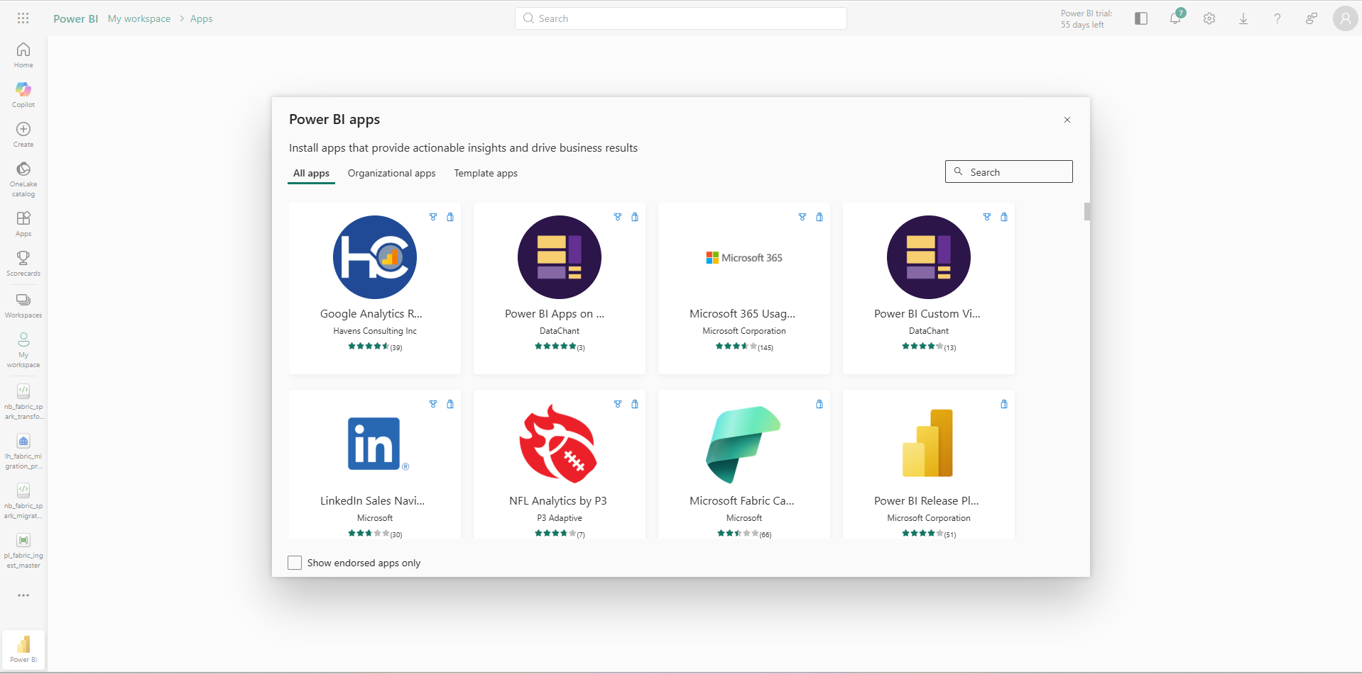
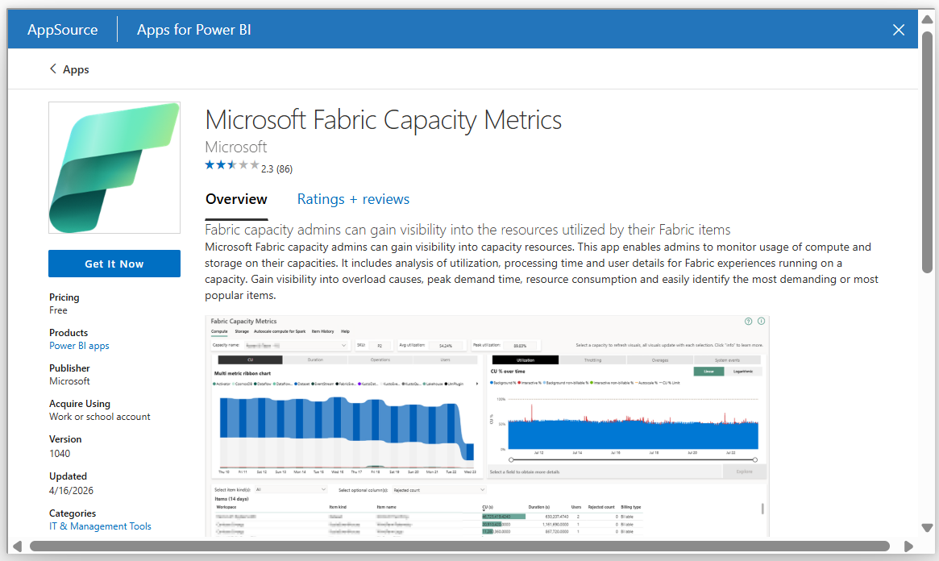
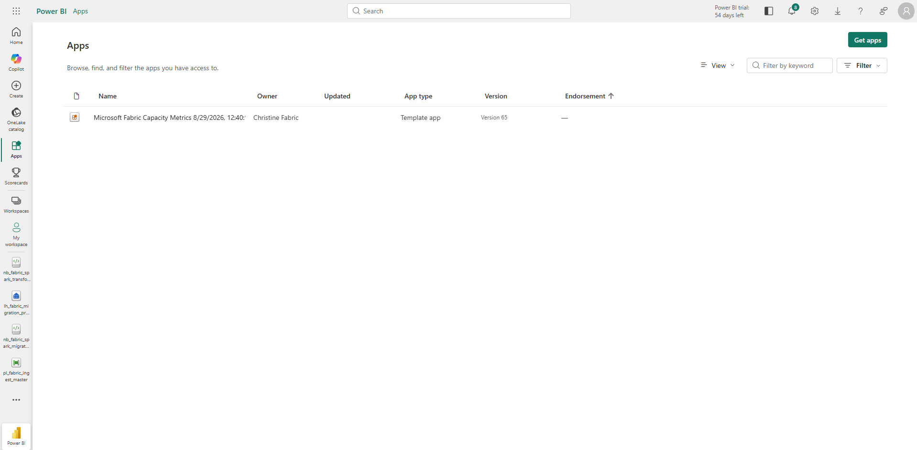
- Open the app, click Connect your data, and set your UTC_offset to 5.5
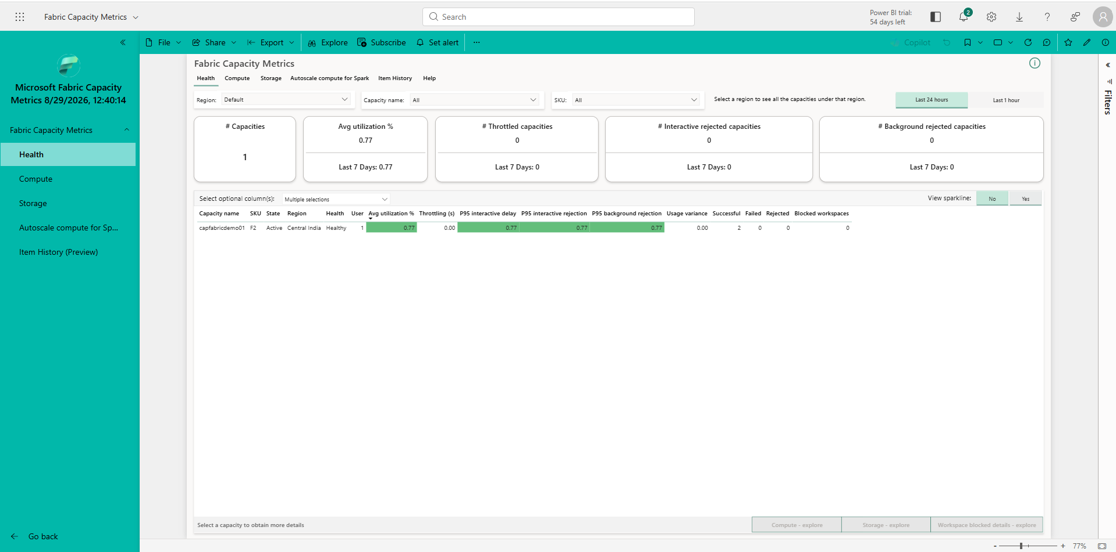
Expected Output: Capacity Metrics dashboard opens, rendering CPU and CU utilization charts.

Phase 3: Network Isolation & Security Baseline Deployment

Step 13: Enable Workspace Managed Virtual Network (VNet) Security
- Inside labskraft-data, click Workspace settings in the top menu bar.
- Select Network security from the side tabs.
- Toggle Workspace Managed VNet to Enabled.
- Click Save.
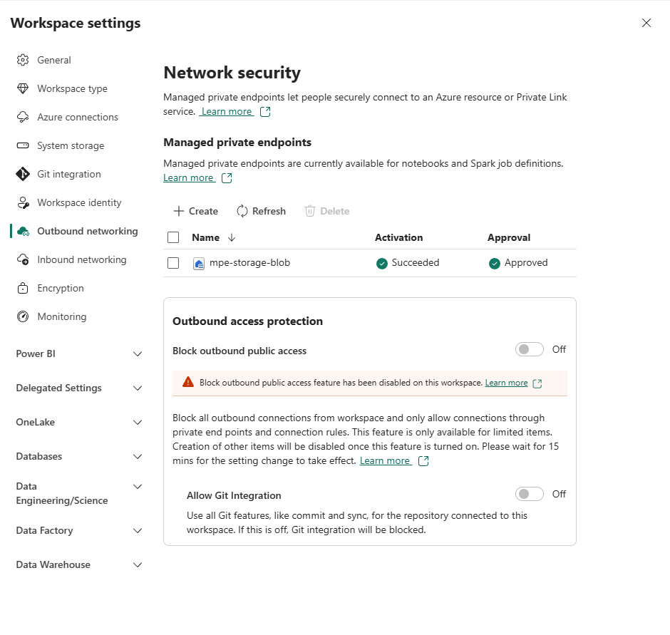
Expected Output: Managed VNet status displays Provisioned / Active.

Step 14: Configure Workspace Private Endpoints for OneLake
- In the Azure Portal, search for Private Link Center in the top search bar and click Private endpoints -> + Create.
- Under the Basics tab, select your Subscription and set Resource Group to LabsKraft-AI. Enter pe-stsynapsechris-dfs as the Name.
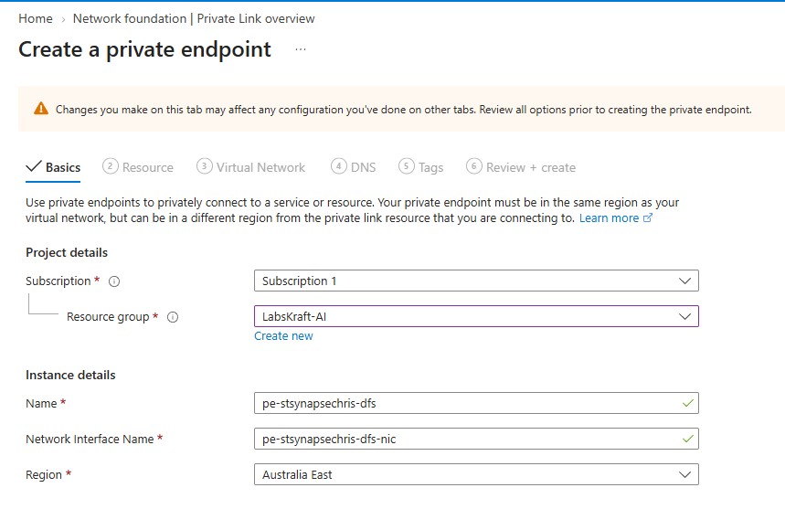
- Under the Resource tab:
  - Resource type: Microsoft.Storage/storageAccounts
  - Target sub-resource: dfs
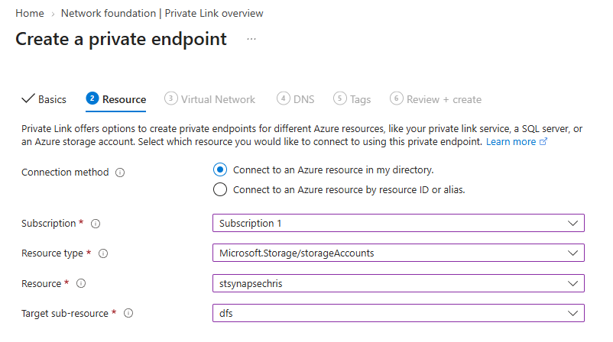
- Under the Virtual Network tab:
  - Select your virtual network (vnet-fabric-eastus).
  - Select your preferred subnet.
  - If not present, create one:
  - Open a new tab in Azure Portal and search for Virtual networks in the top search bar.
  - Click + Create and set:
  - Resource group: LabsKraft-AI
  - Name: vnet-fabric-eastus
  - Region: Australia East (matching your storage account stsynapsechris)
  - Click Review + create -> Create.
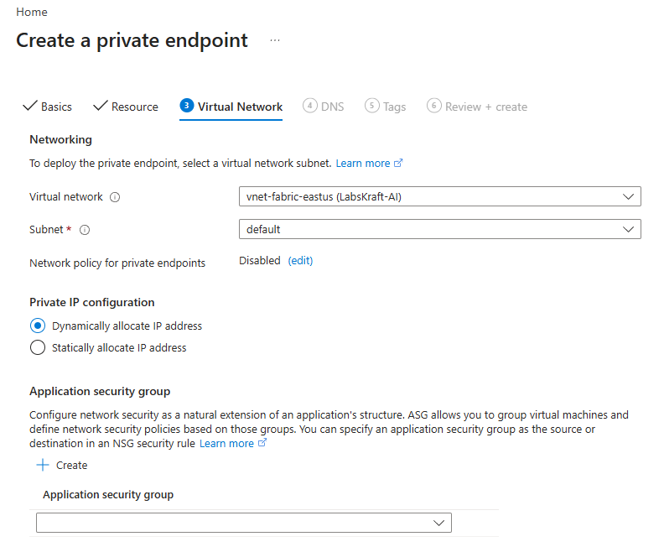
Once deployment finishes, open the newly created private endpoint to verify that the Connection status shows Approved.
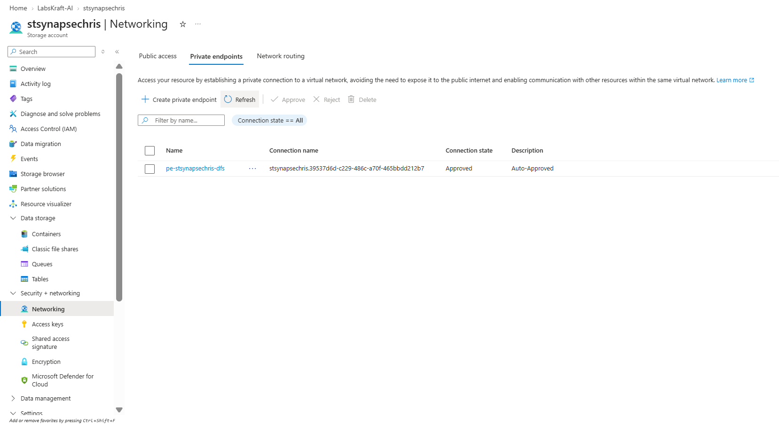
Expected Output: Private Endpoint created with status Approved.
Step 15: Register Self-Hosted Integration Runtime (SHIR) Connection

Step 1: Download & Install the Gateway
- Open a new tab in your browser and download the On-premises Data Gateway (Standard Mode).
- Run the installer on your local VM or machine and complete the setup wizard.

Step 2: Register the Gateway
- When prompted at the end of installation, sign in using your Microsoft Fabric account credentials.
- Select Register a new gateway on this computer.
- Set the Gateway Name (e.g., shir-gateway-demo) and enter a Recovery Key (eg. gatewaykey@123).
- Click Configure.
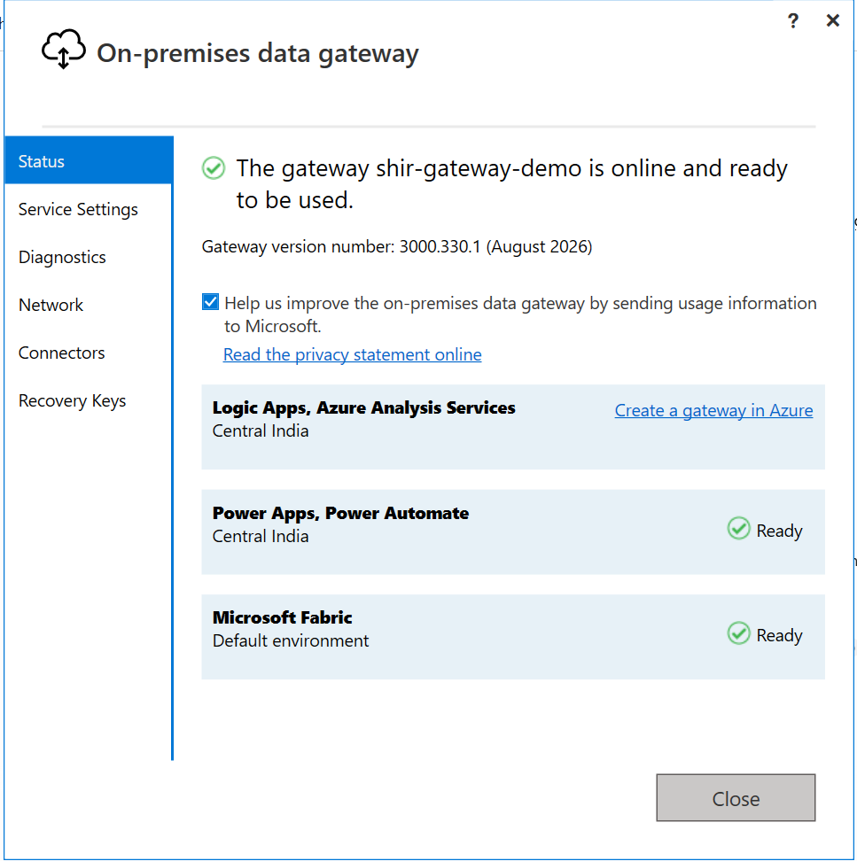
Step 3: Complete Fabric Setup
- In Fabric Portal, Click the 3 dots in the top-right navigation bar of the Fabric portal (next to your profile picture).
- Select Manage connections and gateways from the drop-down menu.
- Click the On-premises data gateways tab (or refresh the page).
- shir-gateway-demo will now appear in the list with a status of Online.
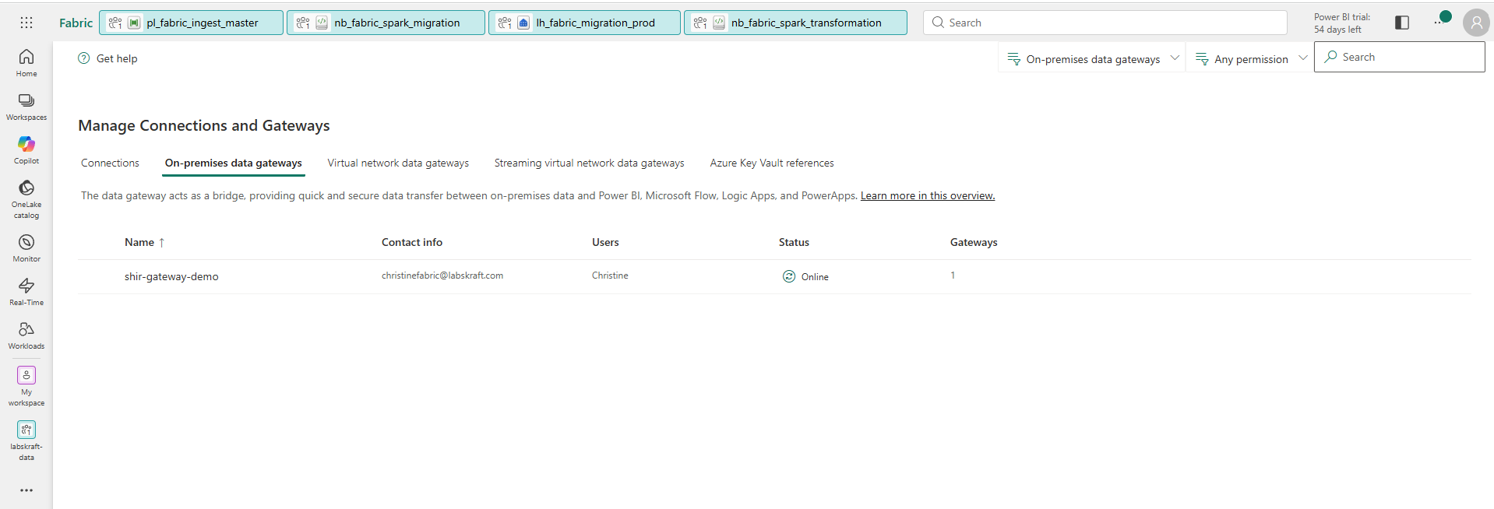
Expected Output: SHIR status shows Connected / Online.
Step 16: Configure Purview Audit Logging for Fabric Security Audits
- Open the Microsoft Purview portal (https://purview.microsoft.com) in your browser.
- In the left navigation menu, click Solutions -> Audit.
- On the Search tab, set the following parameters:
- Date and time range: Select Past 24 hours.
- Record type: leave blank.
- Workspaces: leave blank.
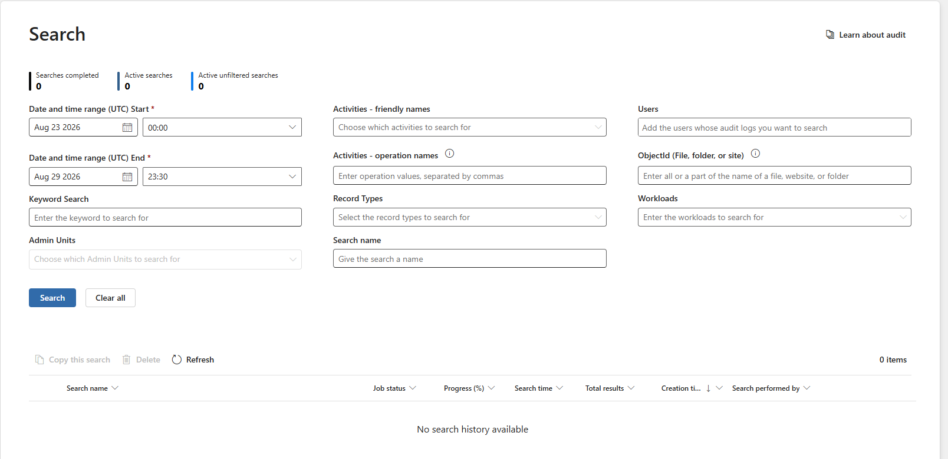
- Click the blue Search button at the bottom and click Refresh until the job status transitions from Queued to Completed.
- Review Results: Inspect the results grid to confirm that administrative or workspace event logs are rendered, fulfilling the audit telemetry verification.
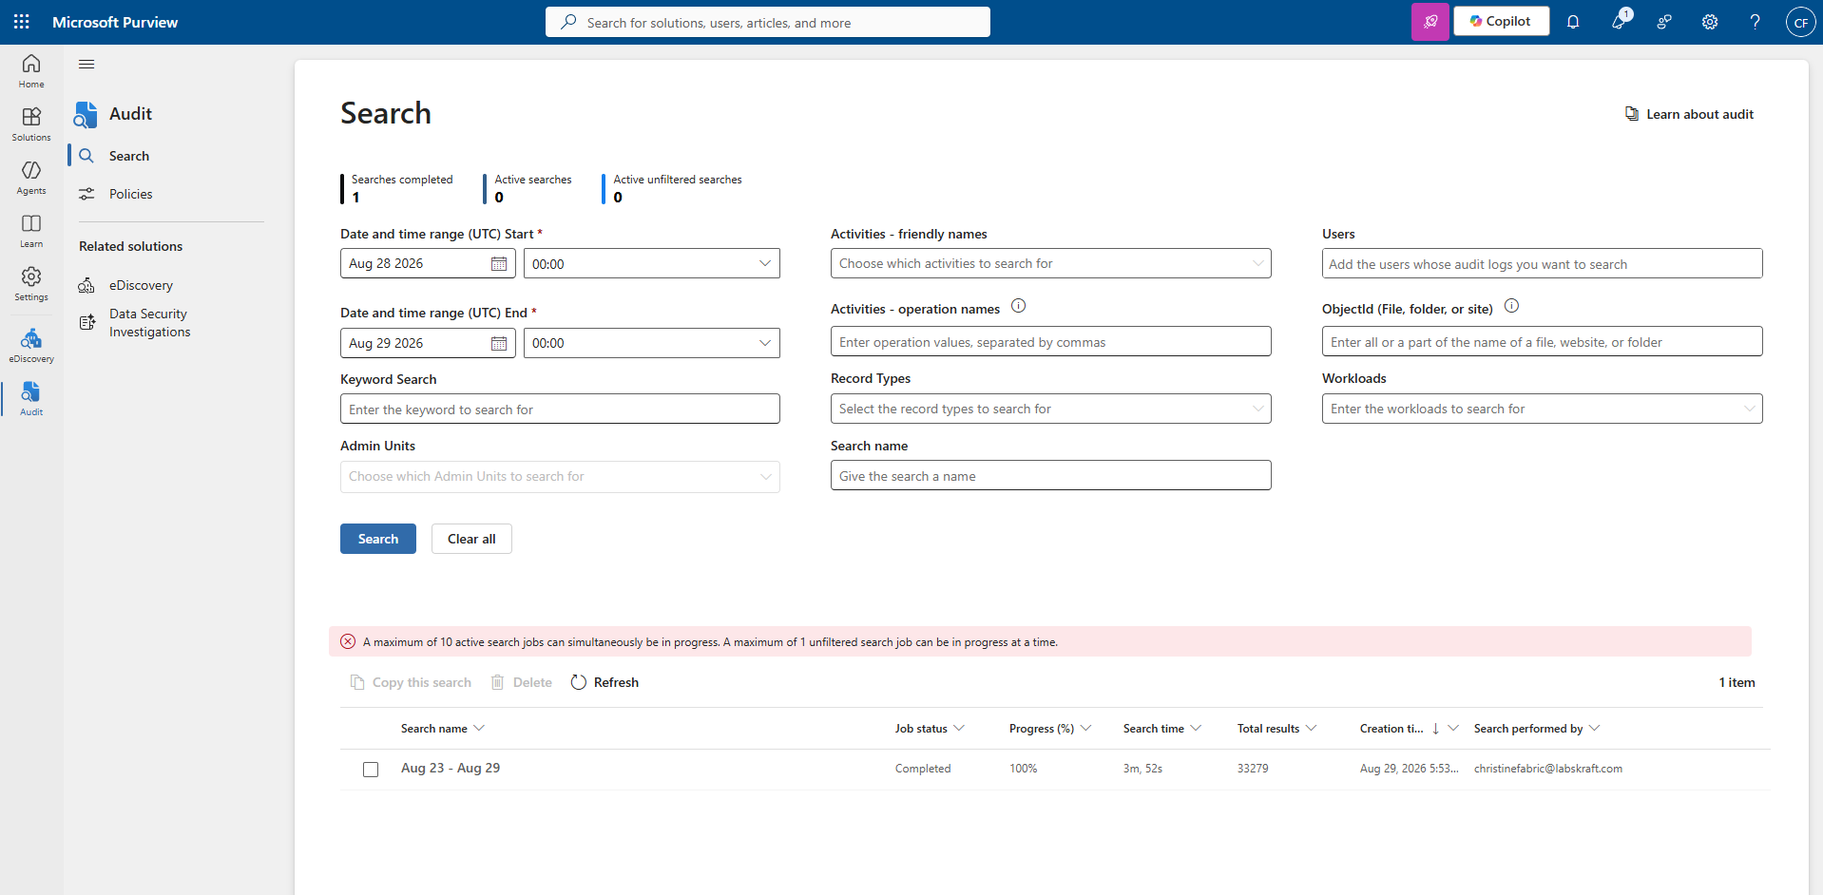
Expected Output: Audit logs render recent Fabric administrative and workspace actions.

Verification Checklist
Run the following validation query inside Cloud Shell to verify Azure Capacity Status:
Bash
az fabric capacity show --capacity-name "capfabricdemo01" --resource-group "rg-synapse-source-demo" --query "{Name:name, State:state, SKU:sku.name}" -o table

Expected Result Table:
Name | State | SKU
capfabricdemo01 | Active | F2

